CAN THO UNIVERSITY
COLLEGE OF INFORMATION AND COMMUNICATION TECHNOLOGY DEPARTMENT OF INFORMATION TECHNOLOGY

  


BASIC THESIS
OF ENGINEERING IN
INFORMATION TECHNOLOGY
(HIGH-QUALITY PROGRAM)

BUILDING A SIMPLE NOTE TAKING APP

Student: Nguyễn Quang Vinh
Student ID: B2105727
Class: 2023-2024 (Cohort K47)
Advisor: Dr. Trương Minh Thái

Cần Thơ, 04/2024
ACKNOWLEDGMENT
I would like to express my sincere gratitude to the following individuals for their invaluable support and contributions throughout the development of this report:
Dr. Lam Nhut Khang, my basic thesis supervisor, guided, suggested, and provided valuable knowledge throughout the research process. My family and friends, for their unwavering support and encouragement throughout my studies.
I am truly grateful for the help and support of my lecturers, family, and friends. in this project. Their contribution is the driving force to complete it.

ABSTRACT
The purpose of the thesis “Building a simple note-taking app.” is to create an android application aimed at individuals seeking efficient task management. The app allows users to capture notes, create checklists, set reminders, receive notifications, and track task progress. The primary objective is to design and implement a practical tool that enhances productivity and organization for users across various backgrounds. The app's intuitive interface prioritizes ease of use and accessibility, catering to the needs of everyday users. This thesis contributes to understanding user-centric design principles in Android app development and highlights the importance of technology in facilitating personal organization and productivity. The project aligns with current trends in digital innovation and aims to address users' evolving needs in a dynamic technological landscape.

PROBLEM STATEMENT INTRODUCTION

INTRODUCTION TO THE THESIS
In today's fast-paced world, individuals often struggle to keep track of important information and tasks efficiently. The problem lies in the inefficiency and disorganization that often accompanies traditional note-taking methods. With the abundance of information, we encounter daily, it becomes increasingly challenging to capture and manage essential details effectively.
As a result, there is a growing demand for a simple and user-friendly note-taking application that can simplify the process of recording, organizing, and accessing information on mobile devices. To address this problem, the "Simple Note" app was created, designed specifically for the Android operating system.
The central objective of this topic is to develop a user-friendly and efficient note-taking application for Android users. The app aims to provide seamless functionality for creating text-based notes and checklists, setting reminders for tasks, and tracking progress of the reminder’s tasks. By addressing these objectives, the app seeks to improve users' ability to organize information effectively and enhance their overall productivity.

RELATED STUDY
The software is built with reference to “Google Keep”, established in 2013, is a versatile note-taking app that simplifies organization. Used for capturing thoughts on the go, creating checklists, or archiving links. It can be used on Android, iOS, and web platforms.

PURPOSE
The main goal of this thesis is to develop an Android application that can handle simple features such as taking notes, creating checklist, creating remainders, receiving notifications, and tracking the progress of task from the reminders. Despite its simplicity, the app can outperform competitors in speed and simplicity, emphasizing a user-friendly design and seamless functionality.

SUBJECT AND SCOPE OF THE THESIS

4.1. SUBJECT OF THE THESIS
The subject of this thesis is the development of an Android application focused on notetaking, checklist management, reminders, notifications, and task progress tracking. The project aims to explore efficient design and implementation strategies to create a user-friendly and high-performance app for Android devices.

4.2. THE SCOPE OF THE THESIS
The scope of the project includes designing and building the Android application with the specified features. This involves developing the user interface for notetaking and checklist creation, implementing reminder and notification functionalities, and integrating task progress tracking within the app. The project will emphasize performance optimization to ensure the app operates faster and more efficiently compared to existing competitors in the market.

RESEARCH METHOD
The research method for this project involves leveraging online courses and available online materials and data to develop the Android application. The project will begin with learning from online resources about Android app development, note-taking features, checklist management, reminders, notifications, and task tracking.
Practical implementation will follow the guidance and tutorials from these online courses and materials. Iterative development based on acquired knowledge and online resources will drive the app's design and functionality. Performance evaluation will be conducted based on personal testing and comparisons with similar apps found online.

STRUCTURE OF THE BASIC THESIS
The layout of the basic thesis includes four main parts: introduction, software requirement and applied technologies, solutions, and results. The introduction will set out the problem, objectives, objects and scope, and research methods. Software requirement and applied technologies will introduce the technologies used in developing the , a detail investigate of the software requirements and the use cases. The solutions will comprise of the data design, use cases and interface for the software. Finally, there is the result, presenting the achieved results, limitations, and development direction of the topic.
Additionally, there is a table of contents instructing everyone on how to use the product.

SOFTWARE REQUIREMENT AND APPLIED TECHNOLOGY

APPLIED TECHNOLOGY

. Android Studio
Android Studio is an integrated development environment (IDE) specifically designed for Android app development. Developed by Google, it provides a comprehensive set of tools for building, testing, and debugging Android applications. It streamlines the development process as well as offering seamless integration with the Android SDK, enabling developers to access a wide range of APIs and libraries to enhance their app functionalities.

2.2. Kotlin
Kotlin is a modern programming language developed by JetBrains, known for its conciseness, safety, and interoperability with existing Java code. Officially supported by Google for Android app development, Kotlin offers features such as null safety, extension functions, and coroutines, enhancing developer productivity and code readability.

2.3. SQLite
SQLite is a lightweight, self-contained, and open-source relational database management system (RDBMS) widely used in embedded systems and mobile applications. Designed for simplicity and efficiency, SQLite requires minimal setup and configuration, making it ideal for small to medium-sized. Despite its compact size, SQLite supports most of the SQL features found in larger database engines, including transactions, triggers, and joins. It operates directly on the device's storage, eliminating the need for a separate server process, which results in faster access times and reduced overhead.

SOFTWARE REQUIREMENT

. MAIN FUNCTION
- Note-taking: Capture and organize thoughts quickly in text form.
- Checklist: Create and manage to-do lists with customizable items and checkboxes.
- Reminder and Notification: Set timely reminders for tasks and receive notifications to stay on track.
- Progress Tracking: Monitor task progress directly after each reminder

2.2. REQUIRED FUNCTIONALITY
- Platform: Android operating system (minimum version specified).
- Note-taking Feature: Ability to create, edit, and delete text notes.
- Checklist Feature: Support for creating and managing checklists with customizable items and completion status.
- Reminder and Notification Feature: Capability to set reminders with timely notifications.
- Progress Tracking Feature: Integration of task progress tracking within reminders, allowing users to self-report task status after each reminder.
- User Interface: Intuitive and responsive user interface following Android Design guidelines.
- Offline Capability: Ability to work offline only.
- Performance: Smooth and efficient performance, optimized for speed and responsiveness.
- Security: Secure storage of user data and notes, adhering to Android security best practices.

2.3. FUNCTIONAL REQUIREMENT

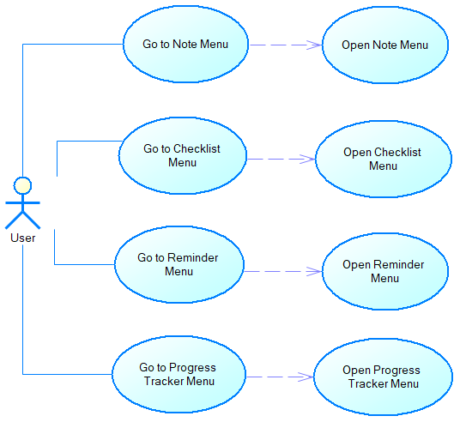
Use case 1 (Navigation Drawer):
Figure 1. Navigation drawer
Use case: Navigation Drawer | ID: UC1
Main actor: User | Priority: 1
Brief description: A menu allowing user to move between activities.
Trigger: User taps on the hamburger button on the toolbar.
Type: External.
Relationship:
+ Association: Go to Note menu, Go to Checklist Menu, Go to Reminder Menu, Go to Progress Tracker Menu.
+ Include: Open Note Menu, Open Checklist Menu, Open Reminder Menu, Open Progress Tracker Menu
+ Extend: None.
+ Generalization: None.
Normal flow:
1. The user taps on the “Go to Note menu” button.
2. The app opens the note activity menu screen.
Alternative flow:
1. If the user is already on the note activity menu.
2. The user taps on the “Go to Checklist menu” button to open the checklist menu.
3. The user taps on the “Go to Reminder menu” button to open the Reminder menu.
4. The user taps on the “Go to Progress Tracker menu” button to open the progress tracker menu.

